**RootAnalyzer**

**A cross-section image analysis tool for automated characterization of root cells and tissues**



Authors:

Joshua Chopin, Hamid Laga, Chun Yuan Huang, Sigrid Heuer, Stanley J. Miklavcic

**Contents**

**Introduction 2**

**Basic Usage 3**

**Selecting Parameters 3**

**Segmentation 4**

**Classification 6**

**Nearest Neighbour Identification 8**

# Introduction

This is a user guide for RootAnalyzer, a software tool designed for the automated analysis of plant root cross section images. The article proposing the software was published in the Plos One journal at “url here”.

The remainder of this guide will introduce the user to each parameter requiring selection for RootAnalyzer to be run successfully, as well as the different stages of the algorithm. The guide illustrates sample results from the important stages of the algorithm, demonstrating which results are acceptable and which would indicate a tuning of parameters is required.

# Basic Usage

Firstly you will need to visit <http://au.mathworks.com/products/compiler/mcr/> to download the compiler that will allow your machine to run software written in matlab, without actually owning matlab. You should download version R2013a (8.1). To begin using the RootAnalyzer algorithm, download and open the *RootAnalyzer_pkg.exe* file from our github repository. The *RootAnalyzer.exe* executable file will then be automatically created and, once accompanied by the compulsory *set.txt* file (explained in further detail below), can be run by simply double clicking the executable.

RootAnalyzer does not utilize a Graphical User Interface (GUI) but rather a command line approach, where the user prescribes a number of parameters using a text file to run the algorithm in an automated manner. The text file must be named ‘set.txt’ and must be placed in the same folder as the RootAnalyzer executable file. The algorithm produces a progression bar while running, alerting the user to how many images have thus far been analysed. The progression bar is however discrete. If one image takes 30 seconds to analyse, the bar will only move every 30 seconds, so do not panic if nothing is happening immediately.

Despite RootAnalyzer being a command-line tool it is not completely a ‘black box’. In the ‘Selecting Parameters’ section we provide a description for how the user can produce intermediate output images to ensure that their parameter selections are suitable. It is advisable to run the algorithm in this manner for a few typical images to ensure that parameter selections are viable, before attempting to analyse a large dataset.

# Selecting Parameters

There are a number of parameters used in the RootAnalyzer algorithm that depend upon image resolution and hence are subject to change with images of different resolutions. The images studied in the RootAnalyzer article are approximately 1024x1024 pixels, making the example parameter values outlined here a good initial choice. The parameters are fed to the RootAnalyzer algorithm through the text file ‘set.txt’ where each new line defines a parameter values. The definition of all parameters is outlined below, along with an example list of parameters, used to analyse the sample images.

Definition of parameters

Directory of images $W$ 
, Window size of local threshold $T$ 
, local threshold value $A_{l}$ 
, large cell area parameter $A_{s}$ 
, small cell area parameter $N$ 
, distance threshold for nearest neighbours algorithm $d_{l}$ 
, parameter for distance of large cells to endodermis boundary $d_{s}$ 
, parameter for distance of small cells to endodermis boundary  
1 - Wheat, 2 – Maize  
1 – Basic output, 2 – Detailed output  
Directory of algorithm output

Parameters for sample images provided

Maize Image

C:\Users\Owner\Documents\images\   
25  
0.05  
100  
2  
50  
25  
10  
2  
2  
C:\Users\Owner\Documents\Results\

Wheat Images

C:\Users\Owner\Documents\images\  
25  
0.05  
1000  
30  
50  
10  
10  
1  
2  
C:\Users\Owner\Documents\Results\

# Segmentation

The first stage in the RootAnalyzer algorithm is segmentation by local thresholding, an approach requiring two parameters. The first parameter is $W$, the width of the window used for the local threshold. The second parameter is $T$, the threshold for which the difference between the intensity of the pixel in question and the mean intensity inside the local window must exceed, in order for the pixel to be classified as belonging to the foreground. Below are some example of satisfactory and unsatisfactory segmentation.

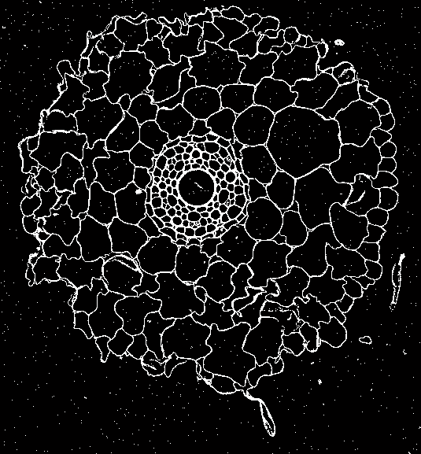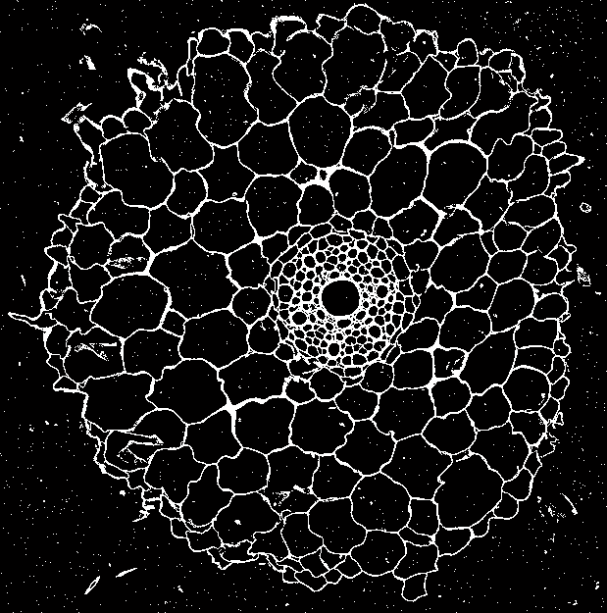

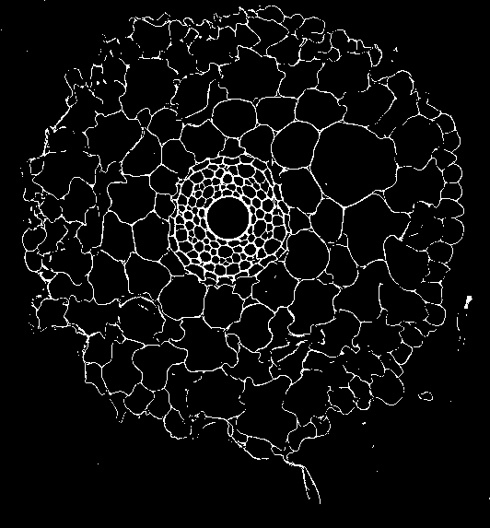 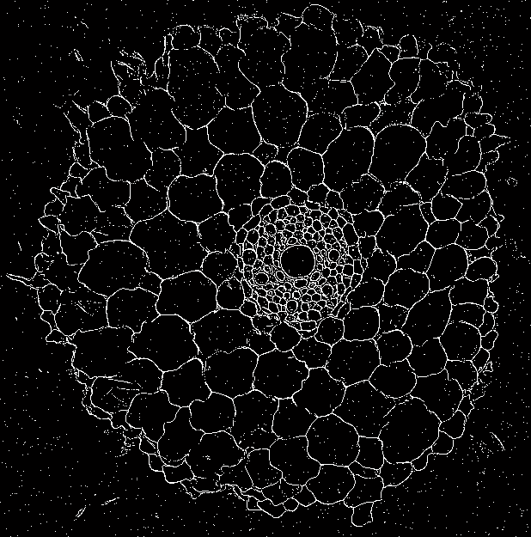

The top left image demonstrates a successful segmentation of the root image. Pieces of noise are infrequent and small in size, making them simple to remove. The boundaries of root cells are thick and there are no gaps in cell walls. The small cells inside the stele have been segmented successfully, with none missed and none fused together. There is a small piece of noise inside the central metaxylem, but this is a common artefact of the segmentation stage and is easily dealt with later in the algorithm.

The top right image also demonstrates a successful segmentation, despite a higher degree of noise. On the left hand side of the root in particular, one can observe large pieces of noise inside a number of cortex cells. This is not a problem for RootAnalyzer as all foreground regions inside a detected cell are later removed. Again, all small cells from the stele and epidermis have been captured accurately.

The bottom left image depicts an unsuccessful attempt at segmentation. In this case the value for $W$, the width of the local threshold’s window, has been set too small. Resultantly, when the algorithm is checking a foreground pixel, the mean intensity inside the window is being affected too heavily by the surrounding foreground intensities and the pixel is mistakenly classified as belonging to the background. This finally results in a number of gaps in the boundaries of cells in the cortex that will be too difficult for the algorithm to repair.

Another unsuccessful segmentation attempt is shown in the bottom right image. Here the value for $T$ has been set too high. A large value of $T$ means that foreground pixels need to differ significantly from the mean intensity in their local window. In images where there is a good contrast between root and background, large $T$ values will introduce a substantial amount of noise and the possibility of foreground pixels being mistakenly classified as background. In these images, where we have normalized the intensities to lie between zero and one, values of $T$ could be taken as low as 0.05.

# Classification

The initial classification of cells as either small or large is determined by thresholding cells by area. The two thresholds $A_{s}$ and $A_{l}$ denote the minimum area of small and large cells respectively. These parameters are quite robust in practice. This is due to RootAnalyzer’s ability to still successfully detect the stele even when a number of ‘small’ cells are detected in the cortex. Below are some example of satisfactory and unsatisfactory initial classification.

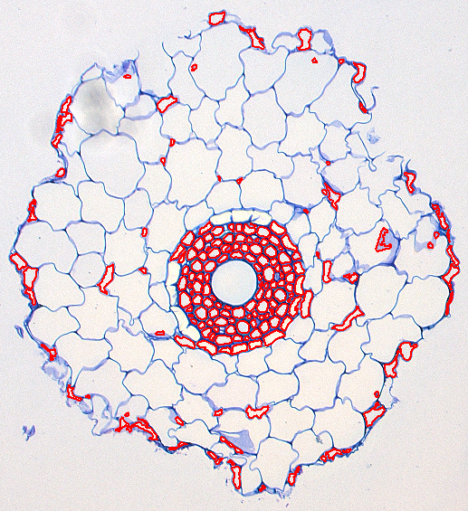 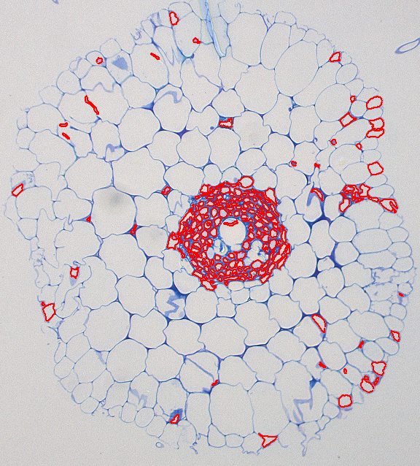

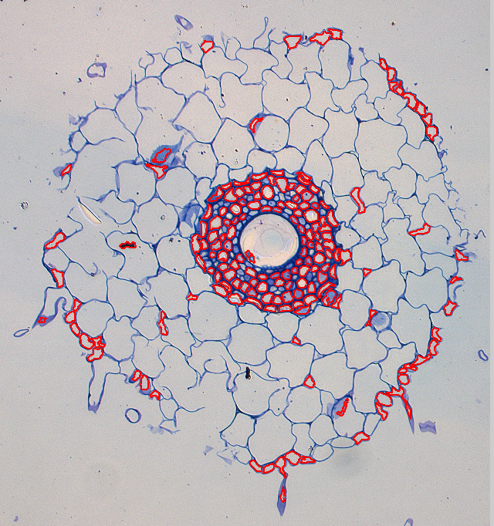 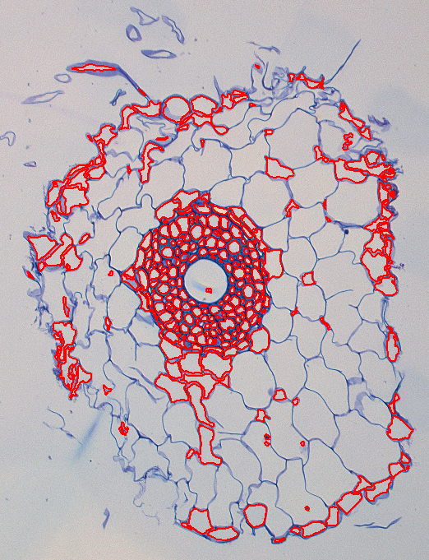

The top left image shows a virtually ideal classification of small and large cells. Almost all stele and endodermis cells are captured and small cells in the cortex are infrequent and approximately evenly distributed.

At first glance the image in the top right appears unsatisfactory. However, a large majority of stele and endodermis cells are captured and the small cells found in the cortex are very infrequent. The large stele cells that have not been captured will later be added to the stele by the algorithm without much difficulty.

The bottom left image is an example of unsatisfactory classification. Due to the value for $A_{s}$ being set too high, many of the small cells in the stele have not been captured. While larger cells can later be added to the stele, the value of $A_{s}$ serves to remove components that are noise rather than cells i.e. a limit on how small cells can be. Hence, these cells cannot be added captured by the algorithm later.

In the bottom right image $A_{l}$ has been set too high and a large number of cortex cells have been classified as stele or endodermis cells. Small errors produced by this misclassification can be rectified but not errors to the extent shown in this image.

Note that while cells categorised as large are not highlighted in these images it is simple to surmise from the images whether the parameter is suitable. As only small cells are highlighted, any cells not highlighted, must either be noise or large cells. It should be a simple task to distinguish between the two. If there are a number of reasonably sized cells not highlighted that should belong to the stele or endodermis area, it probably means the value of $A_{l}$ is too low.

# Nearest Neighbour Identification

In this stage of the algorithm, RootAnalyzer uses a nearest neighbour approach to inspect all small cells that have been identified as possibly belonging to the stele or endodermis and removes the false positives. The main goal of this step is to remove cortex cells that have been classified as stele or endodermis candidates. It is acceptable, and even commonplace, for endodermis cells to be removed during this stage of the algorithm, as it is a simple task for RootAnalyzer to include them again later on. It is a much more difficult task to remove cortex cells that have persisted through this stage

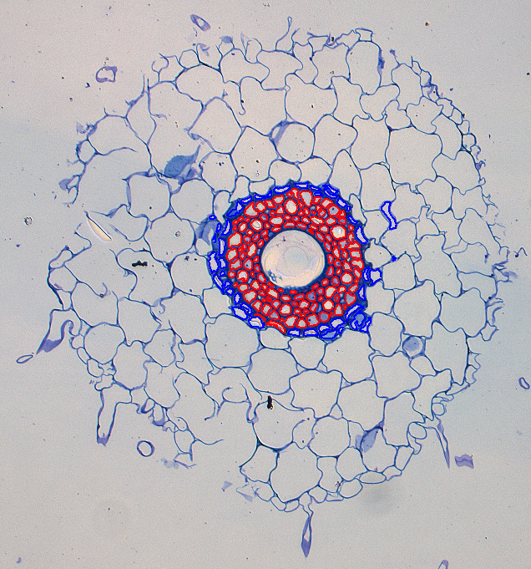 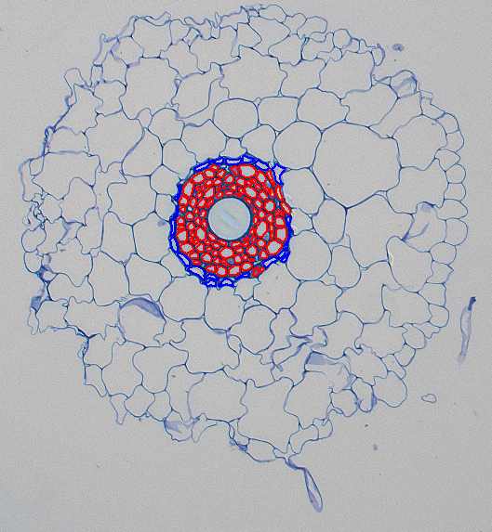

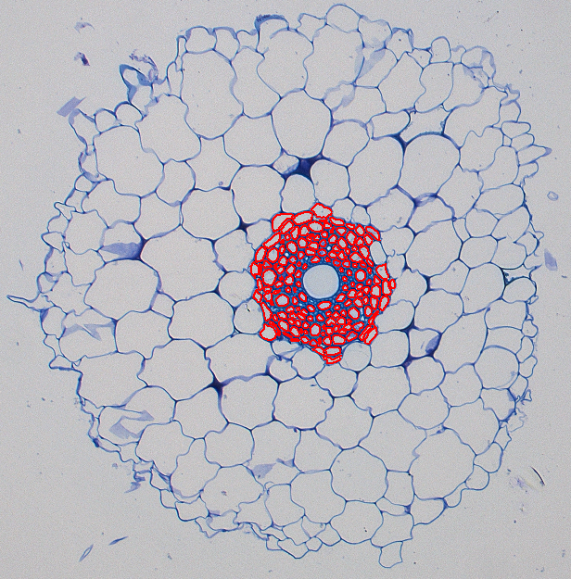 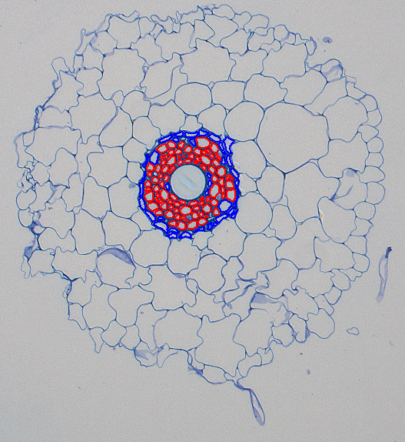

In the above images, cells highlighted as red are the cells initially considered as candidates for the stele and endodermis. Blue cells are cells that were initially considered as candidates but have been removed during the nearest neighbours identification.

The top left image depicts a successful nearest neighbours identification stage. A number of cortex cells that were mistakenly included have now been removed. This includes not only the disjoint cell on the right, but cortex cells that are virtually touching endodermis cells. Note that while almost all endodermis cells have been removed, as stated above, it is a trivial task for RootAnalyzer to add these cells back to the endodermis at a later stage. The important result is that the cortex cells have been removed from the group.

The image in the top right depicts a more subtle version of the top left image. In this scenario almost all endodermis cells have been removed in order to remove only one cortex cell, near the top right section of the endodermis. By the end of the algorithm this will still result in a successful characterization of cells and further demonstrates the relative importance of removing cortex cells from this stage.

The bottom left image depicts a scenario where the distance threshold $N$, for the nearest neighbour algorithm has been set too high. A large value of $N$ indicates that neighbouring cells can still be very far away from each other and both belong to the stele or endodermis. As such, the algorithm has failed to remove a number of cortex cells.

The bottom right image depicts a scenario where $N$ has been set too small. This means that neighbouring cells can only belong to the stele or endodermis if their centres are extremely close together. One can see that this rarely effects very small cells inside the stele, but results in some of the larger stele cells being removed. While the removal of endodermis cells during this stage is acceptable, the removal of stele cells is not preferred.